**Restaurant Management System(Tableau-Concept)**

Q1) Create a dashboard for senior management to view sales of restaurants for the last six months. Make assumptions as appropriate and create the dashboard using your own mock data.

Ans) The dashboard of sales of restaurant for last six months is shown below:

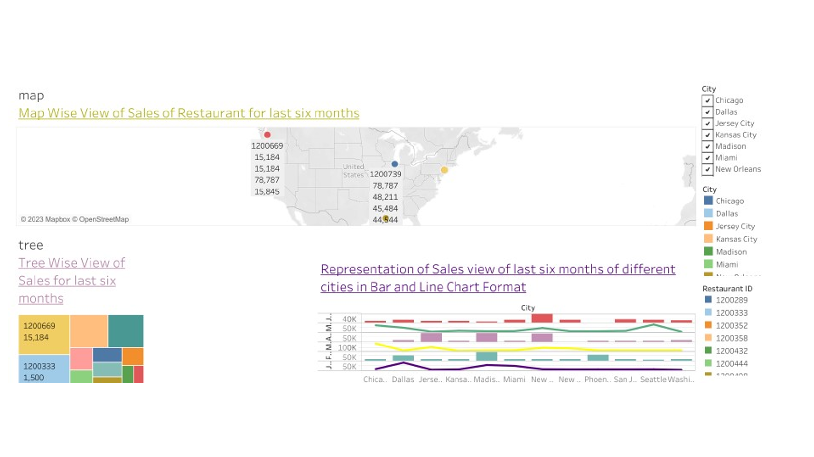

For detailed understanding of the above dashboard, kindly click on the below link

[https://public.tableau.com/app/profile/shivani.priya8178/viz/Restsales/JanSales?publish=yes](https://public.tableau.com/app/profile/shivani.priya8178/viz/Restsales/JanSales?publish=yes" \o "Dashboard-1(Sales of Restaurant))

Q2) Create a dashboard to show which zone (Zone 1, 2, 3, or 4) has highest sales. Make assumptions as appropriate and create the dashboard using your own mock data.

Ans)

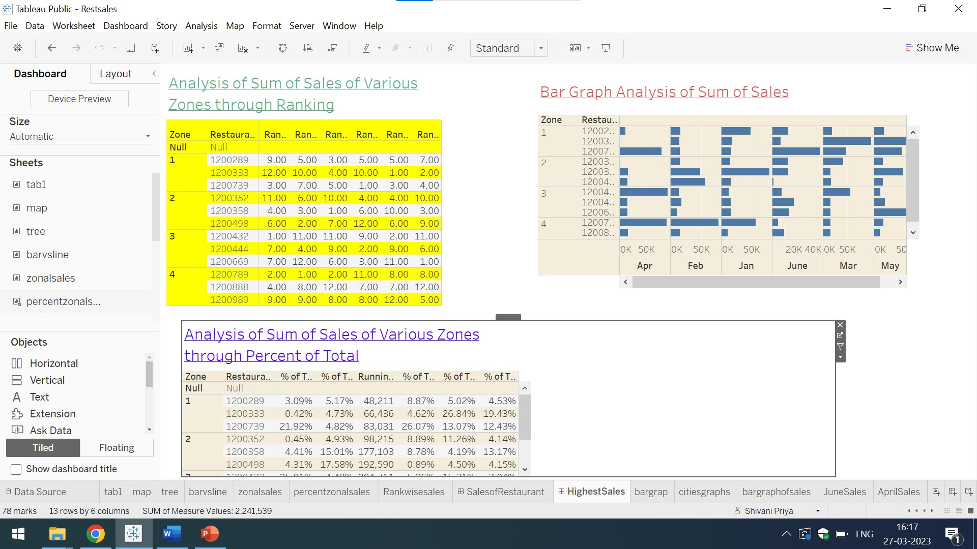

From the above mentioned dashboard,it is clear that Zone 4 has highest Sales. From Rank wise Sales Analysis it is clear that zone 4 is having highest sales

1)-Create a bar graph for San Jose, Madison, and New York showing the sales. Label the chart drawn correctly so that senior management gets a clear report of sales.

Ans) The bar graph for San Jose, Madison, and New York showing the sales.

Is mentioned below:

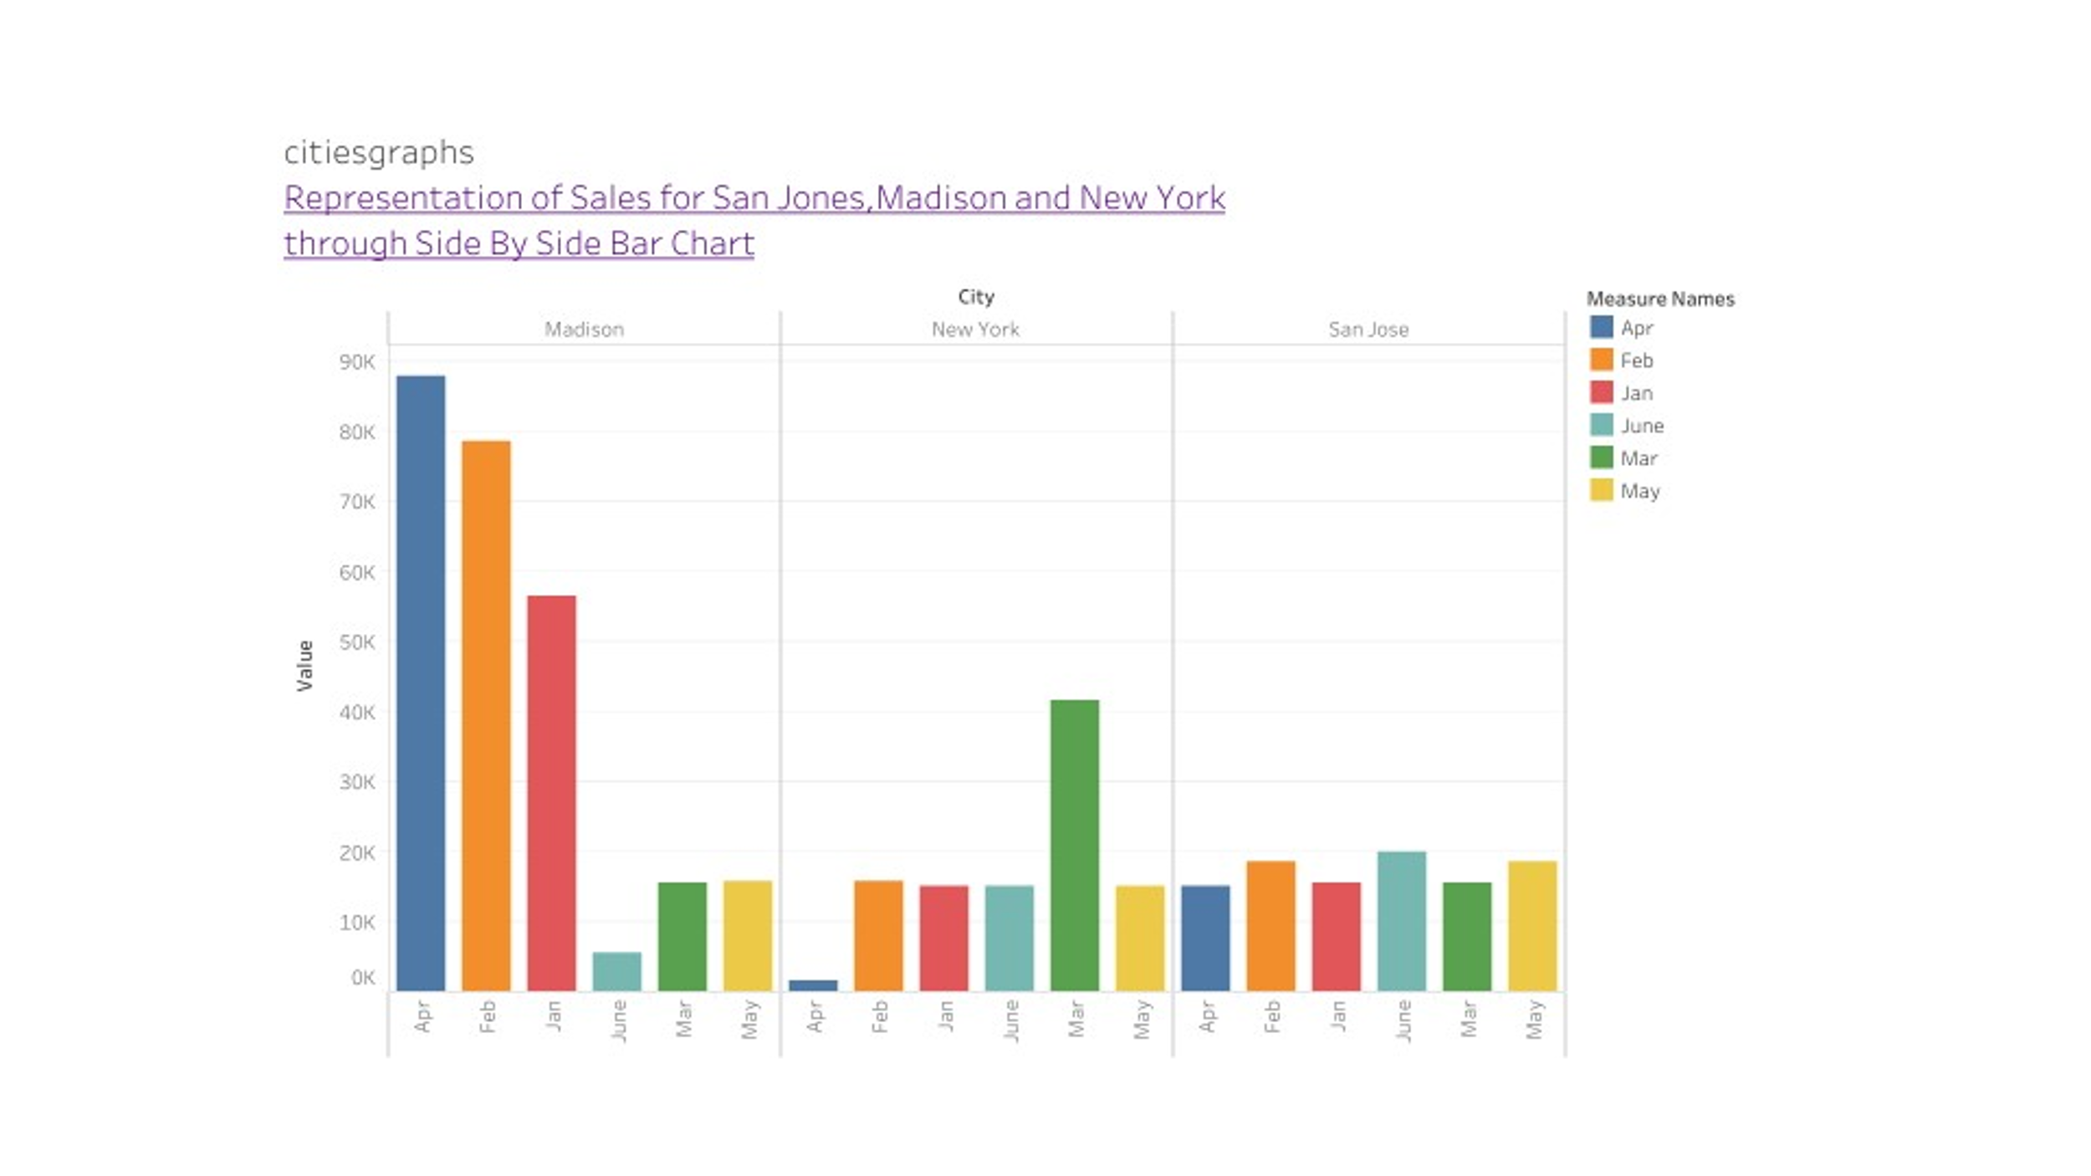

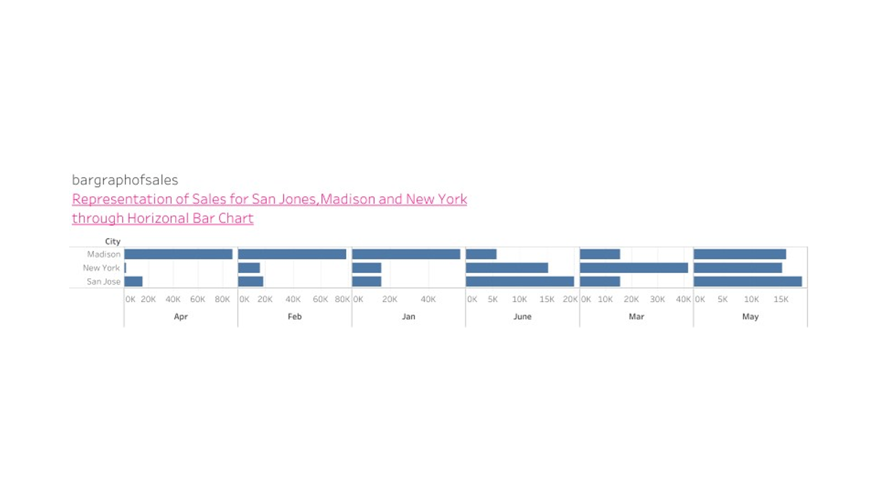

For detailed view of bar graph click on the below mentioned link

<https://public.tableau.com/app/profile/shivani.priya8178/viz/Restsales/HighestSales?publish=yes>

Q2) Arrange the data above in excel in an ascending and descending order for each city

Ans) The original excel sheet data is:

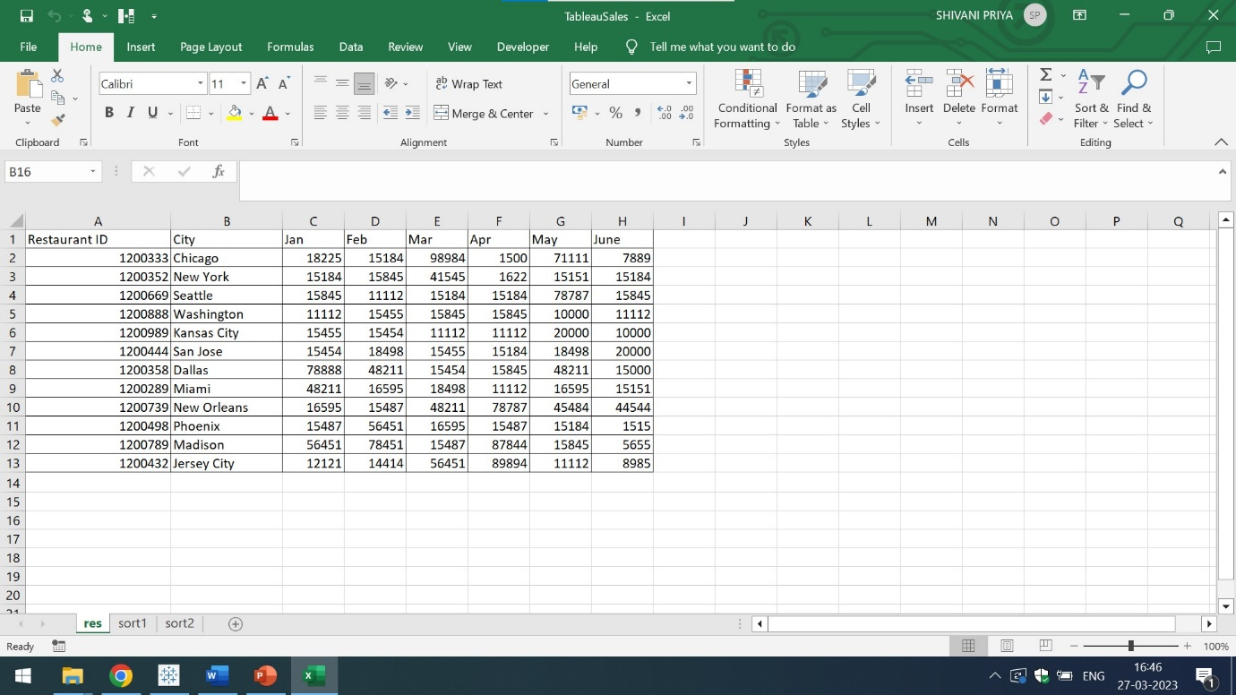

The arrangement of above data in excel in an ascending order for each city is:

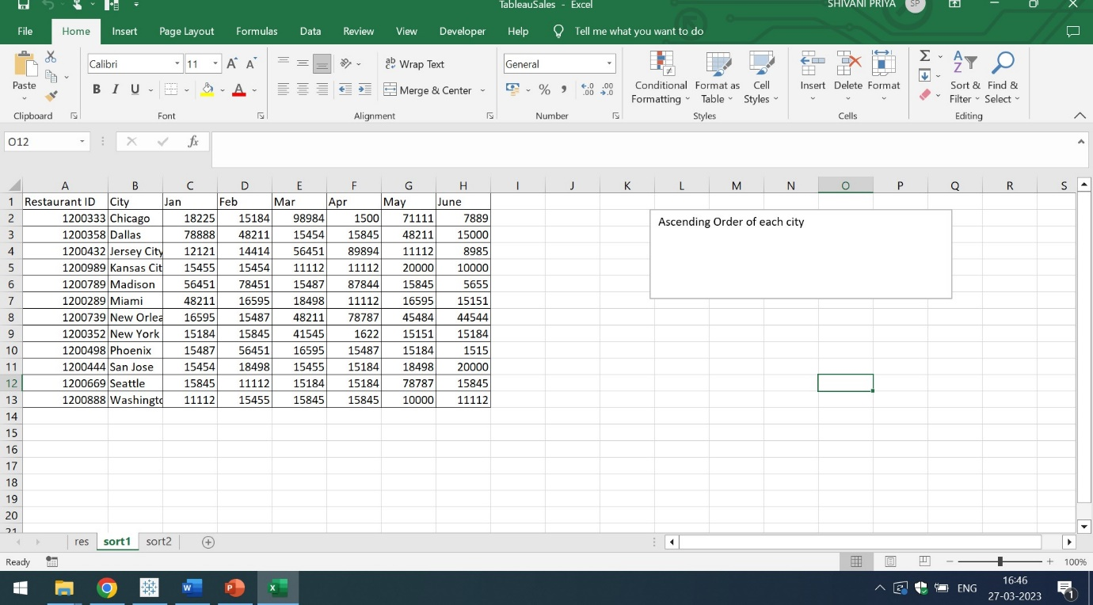

The arrangement of data in excel in descending order of city is:

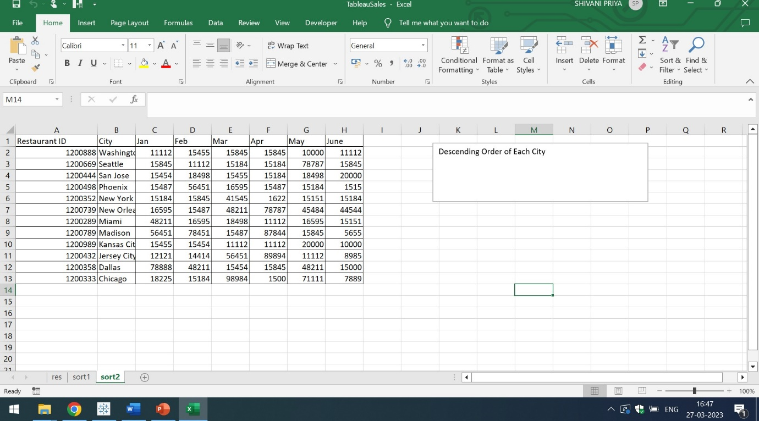

Question 2:

In the above chart for restaurant ID 1200789, find the sales for the month of June

Ans) The sales for the month of June for Restaurant ID 1200789 is:

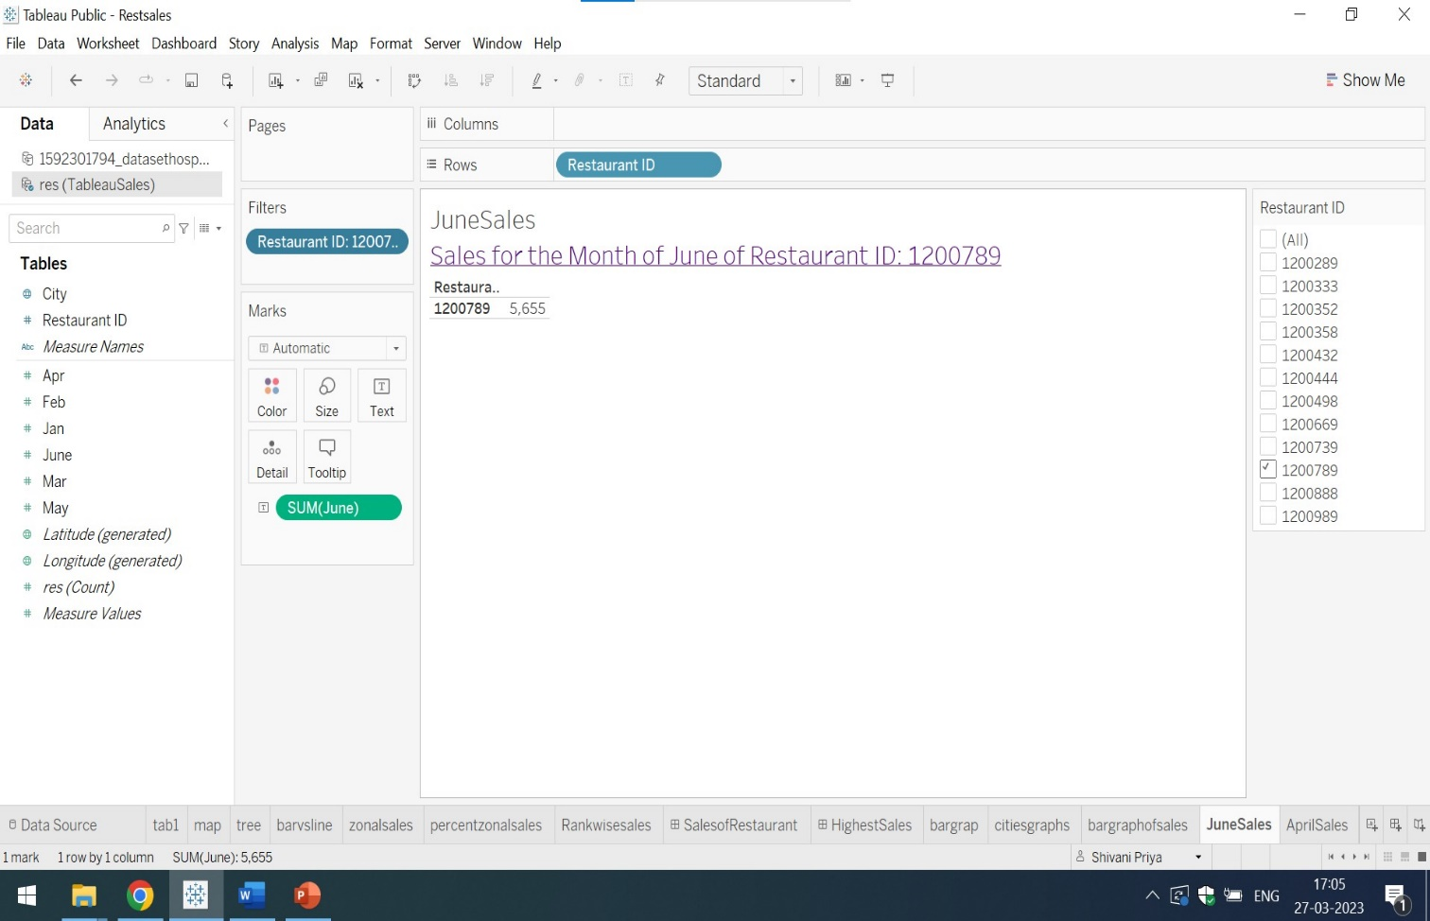

The sales for the month of April for Restaurant ID 1200739, is:

|  |  |  |
| --- | --- | --- |
| **Restaurant ID** | **Month** | **Sales** |
| 1200789 | June | 5655 |
| 1200739 | April | 78,787 |
| 1200352 | January | 15,184 |

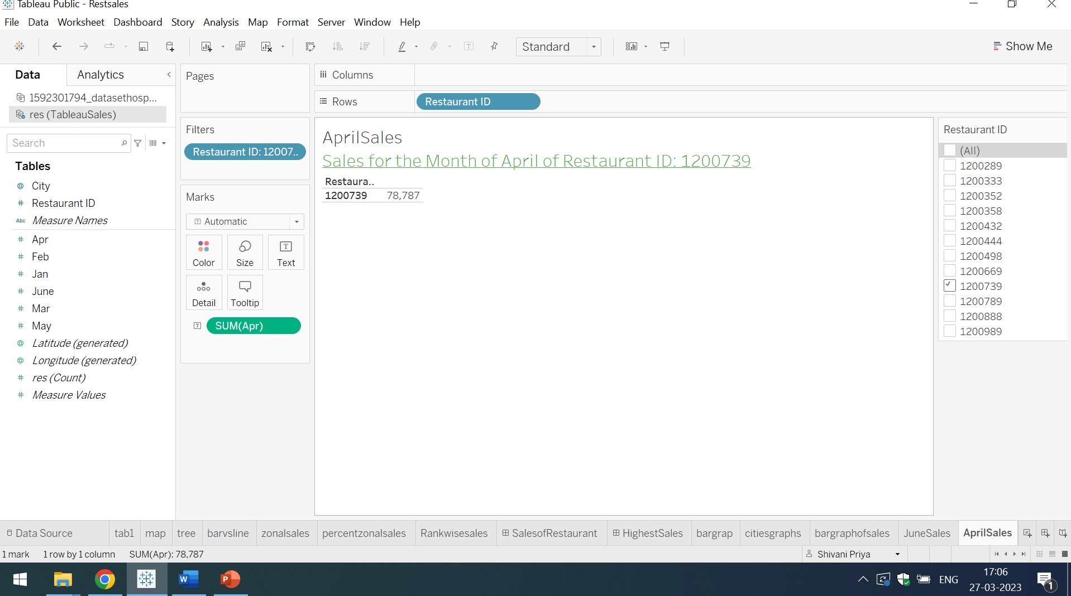

The sales for the month of January for Restaurant ID 1200352, is:

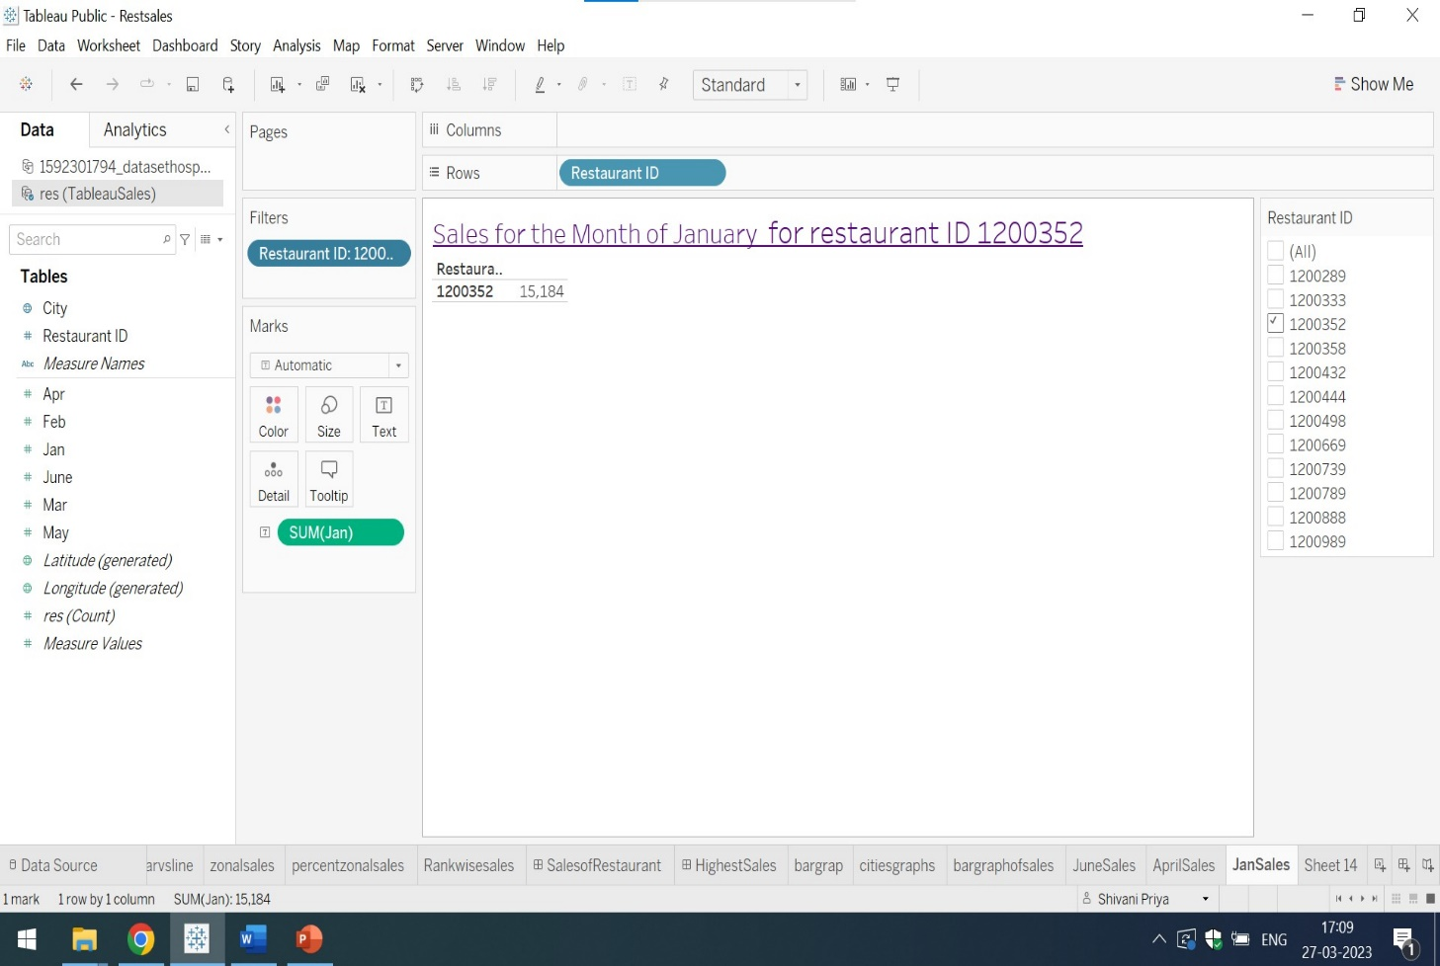

For detailed View and Analysis of Dashboard click on:

<https://public.tableau.com/app/profile/shivani.priya8178/viz/Restsales/JanSales?publish=yes>

Click on the above mentioned various tabs and view the sheets accordingly